Analytical Problem Solving

Warehouse Robot Search Problem (BFS vs. DFS)

- PEAS Description

PEAS Element | Description for Warehouse Delivery Robot
Performance Measure | Minimizing total path cost (number of moves/steps taken), successfully reaching cell (5,5) with the package, avoiding obstacles/shelving units, and avoiding infinite loops or off-grid moves.
Environment | A 5×5 grid warehouse matrix with obstacle cells at (2,2), (2,3), (3,3), (4,2), and (4,4). The grid boundary is [1,5]×[1,5].
Actuators | Wheel motors or drive mechanisms enabling moves in 4 cardinal directions: Up, Down, Left, Right.
Sensors | Position sensor/wheel encoders (e.g., GPS, indoor positioning, or odometry) to determine current cell (x,y), and proximity sensors/LiDAR/obstacle maps to detect boundary edges and blocked shelves.

B. Agent Classification

The best suited agent type for this task is a Goal-Based Agent (or a Utility-Based Agent if optimizing path cost dynamically under variable traffic).

Justification: A simple reflex agent operates purely on condition-action rules based on immediate percepts (e.g., "if wall ahead, turn right"). In a maze with obstacles, a simple reflex agent easily gets trapped in infinite loops or dead ends because it lacks foresight. A goal-based agent combines current state perception with explicit goal information—here, reaching cell (5,5)—and plans a sequence of actions (using search algorithms) to safely navigate around blocked shelves to reach that target destination.

C.Formal Search Problem Formulation

State Space: Set of all valid grid coordinates (x,y) where x,y∈{1,2,3,4,5} and (x,y)∈

Obstacles.

Obstacles={(2,2),(2,3),(3,3),(4,2),(4,4)}

Initial State: (1,1)

Goal State: (5,5)

- Actions: Actions(s)⊆{Up,Down,Left,Right}:

- Up: Moves from (x,y) to (x−1,y)

- Down: Moves from (x,y) to (x+1,y)

- Left: Moves from (x,y) to (x,y−1)

- Right: Moves from (x,y) to (x,y+1)
(An action is valid only if the resulting coordinate stays within the 5×5 grid bounds and is not in Obstacles.)

Transition Model: R(s,a)=s

where ‘s is the resulting coordinate after executing action a from state s.

Path Cost Function: C(s,a,s)=1 for each valid move. The total path cost g(n) is the sum of step costs along the path (i.e., the total number of moves).

D. Breadth-First Search (BFS) Execution

Order of action expansion: Up, Down, Left, Right (standard convention; invalid/blocked/visited nodes are ignored).

Let the queue (Frontier) store path nodes as [Current_State, Path_So_Far].

Visited set tracks visited states to avoid redundant expansion.

Step-by-Step Expansion:
Step 0:

Pop: (1,1)

Frontier: [ (1,2) ], [ (2,1) ]
Visited: {(1,1),(1,2),(2,1)}

Step 1:

Pop: (1,2)
Expand (1,2):
Down: (2,2) — Blocked
Left: (1,1) — Visited
Right: (1,3) — Valid
Frontier: [ (2,1) ], [ (1,3) ]

Visited: add (1,3)

Step 2:

Pop: (2,1)

Expand (2,1):

Up: (1,1) — Visited

Down: (3,1) — Valid

Right: (2,2) — Blocked

Frontier: [ (1,3) ], [ (3,1) ]

Visited: add (3,1)

Step 3:

Pop: (1,3)

Expand (1,3):

Down: (2,3) — Blocked

Right: (1,4) — Valid

Frontier: [ (3,1) ], [ (1,4) ]

Visited: add (1,4)

Step 4:

Pop: (3,1)

Expand (3,1):

Down: (4,1) — Valid

Right: (3,2) — Valid

Frontier: [ (1,4) ], [ (4,1) ], [ (3,2) ]

Visited: add (4,1),(3,2)

Step 5:

Pop: (1,4)

Expand (1,4):

Right: (1,5) — Valid

Frontier: [ (4,1) ], [ (3,2) ], [ (1,5) ]

Visited: add (1,5)

Step 6:

Pop: (4,1)

Expand (4,1):

Down: (5,1) — Valid

Right: (4,2) — Blocked

Frontier: [ (3,2) ], [ (1,5) ], [ (5,1) ]

Visited: add (5,1)

Step 7:

Pop: (3,2)

Expand (3,2):

Up: (2,2) — Blocked

Down: (4,2) — Blocked

Right: (3,3) — Blocked

(No new valid neighbors)

Frontier: [ (1,5) ], [ (5,1) ]

Step 8:

Pop: (1,5)

Expand (1,5):

Down: (2,5) — Valid

Frontier: [ (5,1) ], [ (2,5) ]

Visited: add (2,5)

Step 9:

Pop: (5,1)

Expand (5,1):

Right: (5,2) — Valid

Frontier: [ (2,5) ], [ (5,2) ]

Visited: add (5,2)

Step 10:

Pop: (2,5) → Adds (3,5) to frontier

Step 11: Pop (5,2) → Adds (5,3) to frontier

Step 12: Pop (3,5) → Adds (4,5) to frontier

Step 13: Pop (5,3) → Adds (5,4) to frontier

Step 14: Pop (4,5) → Adds (5,5) — Goal reached! (also accessible via (5,4)→(5,5))

BFS Path: (1,1) -> (1,2) -> (1,3) -> (1,4) -> (1,5) -> (2,5) -> (3,5) -> (4,5) -> (5,5)

(Alternative equally optimal path via bottom edge: (1,1) -> (2,1) -> (3,1) -> (4,1) -> (5,1) -> (5,2) -> (5,3) -> (5,4) -> (5,5))

Total Cost: 8 moves

- Depth-First Search (DFS) Execution

Order of action expansion: Up, Down, Left, Right (pushed onto Stack; top of stack popped next).

Step-by-Step Expansion:
Start: Push (1,1) onto Stack.

Pop (1,1): Neighbors: (1,2) [Right], (2,1) [Down]. Stack pushes Down then Right ⟹ Top is (1,2) or (2,1) depending on insertion order. Using standard move priority order Up, Down, Left, Right:

From (1,1), Down gives (2,1), Right gives (1,2).

- Traversal moves down depth-first along (2,1)→(3,1)→(4,1)→(5,1)→(5,2)→(5,3)→(5,4)→(5,5).

- Traversal Sequence: (1,1)⟶(2,1)⟶(3,1)⟶(4,1)⟶(5,1)⟶(5,2)⟶(5,3)⟶(5,4)⟶(5,5)

- DFS Path: (1,1) -> (2,1) -> (3,1) -> (4,1) -> (5,1) -> (5,2) -> (5,3) -> (5,4) -> (5,5)

- Total Cost: 8 moves.

- Comparison of BFS vs DFS for this Scenario

Metric | BFS | DFS
Completeness | Complete (always finds a solution on finite grids). | Complete (in finite state space with cycle detection).
Optimality | Optimal (guarantees shortest path since step costs are uniform = 1). | Not Optimal in general (depends on branching order; can return deep non-optimal paths).
Time Complexity | O(b^d), where b is branching factor (≤4) and d is goal depth (8). | O(b^m),where m is maximum grid depth.
Space Complexity | O(b ^d ) — holds all frontier nodes per level in memory. | O(b⋅m) — requires linear memory proportional to max depth.

- Algorithm Suitability: BFS is strictly more suitable for this warehouse delivery problem. Because step costs are uniform (each move costs 1 unit of battery/time), BFS guarantees finding the shortest, most fuel/time-efficient path to cell (5,5). DFS does not guarantee an optimal route and could lead the robot along unnecessary, convoluted detours in larger grid layouts.

Code Implementation

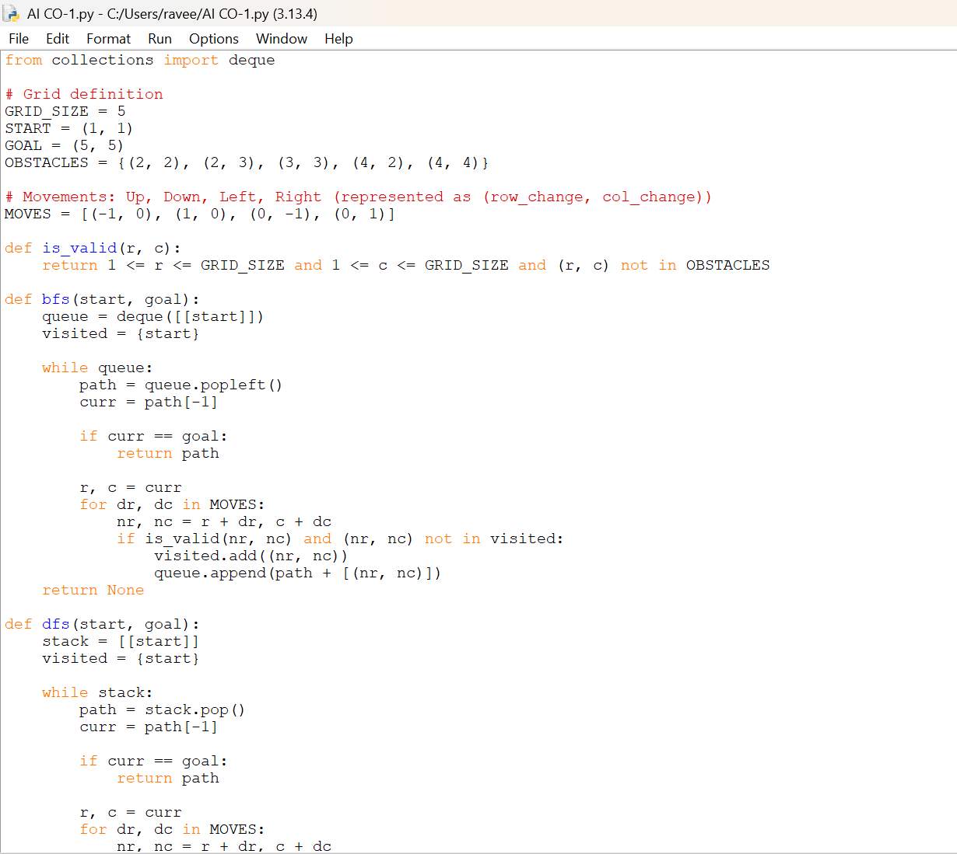
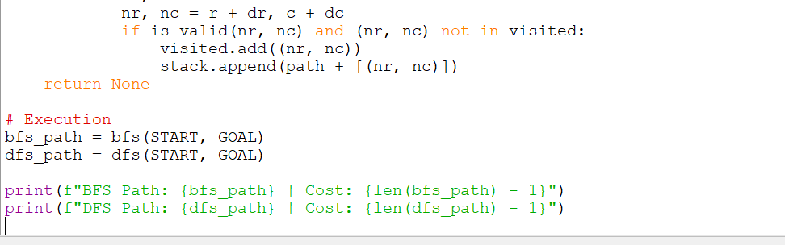

OUTPUT:

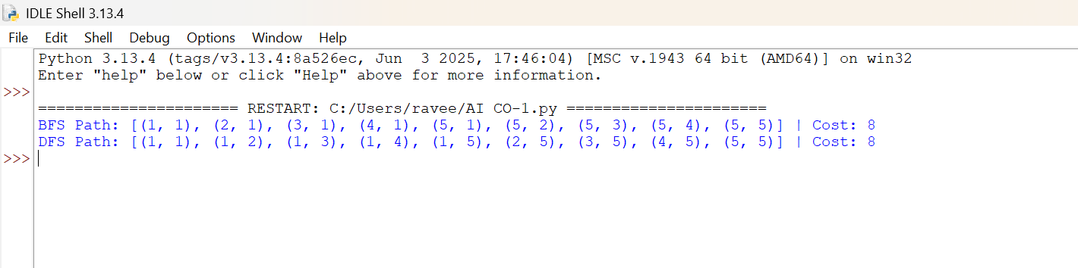

CONCLUSION

- Goal-Based Agent: The robot navigates a 5×5 grid from (1,1) to (5,5) while avoiding 5 shelf obstacles using cardinal movements with uniform cost 1.

- Optimal Path & Cost: Both BFS and DFS locate a 9-node path—such as (1,1) -> (2,1) -> (3,1) -> (4,1) -> (5,1) -> (5,2) -> (5,3) -> (5,4) -> (5,5)—yielding an optimal cost of 8 moves.

- Preferred Algorithm: BFS is ideal for this warehouse environment because it guarantees finding the shortest, most energy-efficient route under uniform step costs.

